Report Structure

- 1. Introduction
- 2. Problem Statement
- 3. Data Collection and Preprocessing
- 4. Exploratory Data Analysis (EDA)
- 5. Feature Engineering
- 6. Model Selection and Training
- 7. Hyperparameter Tuning
- 8. Model Evaluation
- 9. Feature Importance Analysis
- 10. Business Implications
- 11. Conclusion and Future Steps

Enhancing Real Estate Investment Decisions
with Predictive Modelling

1. Introduction
The real estate and housing market is one of the most important sectors of the economy because residential properties represent a major form of investment for individuals, families, financial institutions, and real estate companies. The value of a house is influenced by a large number of factors, including its location, size, construction quality, age, number of rooms, garage facilities, basement area, neighbourhood, and overall condition. Because these factors interact with one another, determining an appropriate property value using only traditional methods can be difficult and time-consuming.
In a competitive real estate market, accurate property valuation is essential for making effective investment and business decisions. Buyers need to understand whether a property is reasonably priced, while sellers and real estate companies need to determine suitable asking prices. Similarly, companies entering a new housing market need reliable estimates of property values before deciding which properties to acquire, develop, or invest in. Incorrect valuation can result in overpricing, under pricing, poor investment decisions, and financial losses.
Traditionally, property prices have often been estimated using manual comparisons with similar properties, expert knowledge, historical prices, and basic statistical methods. Although these approaches can provide useful information, they may not fully capture the complex relationships between dozens of property characteristics. The increasing availability of structured housing data provides an opportunity to use Data Science and Machine Learning to develop more systematic and data-driven valuation methods.
1.1 Role of Data Science in Real Estate
Data Science plays an important role in transforming raw real estate data into meaningful insights. Housing datasets generally contain information about various characteristics of properties, such as:
- Overall quality and condition of the property
- Living area and floor area
- Number of bedrooms and bathrooms
- Basement facilities
- Garage characteristics
- Year of construction and renovation
- Lot size
- Neighbourhood and location
- Building type
- Exterior and interior characteristics
- Sale price
Machine Learning algorithms can analyse these variables simultaneously and learn the relationships between property characteristics and their corresponding sale prices. Instead of depending entirely on manually defined rules, a predictive model can identify patterns from historical property transactions and use those patterns to estimate the value of previously unseen properties.
For example, a property with higher overall quality, larger living space, a finished basement, a good neighbourhood, and better garage facilities may generally have a higher market value. However, the effect of each characteristic is not necessarily independent. Machine Learning models can capture many of these interactions and nonlinear relationships.

1.2 Project Context
This project is developed for the business case of Surprise Housing, a US-based housing company that is considering expansion into a new real estate market. Before making investment decisions in a new market, the company requires a reliable understanding of how different property characteristics influence house prices.
The supplied dataset contains residential property attributes and sale prices from the Ames housing dataset. It provides a suitable basis for developing a predictive modeling framework for property valuation. The dataset contains a wide range of numerical and categorical variables describing residential properties.
The training dataset contains 1,168 property records and 81 columns, including the target variable SalePrice. The test dataset contains 292 property records and 80 columns, where the sale price is not provided. The project therefore uses the training data to learn the relationship between property characteristics and sale price and then applies the trained model to generate price predictions for the test properties.
1.3 Importance of the Project
The primary importance of this project is that it demonstrates how historical housing data can be converted into a practical predictive decision-support system.
The project focuses on the following important objectives:
- Understanding housing data
Analyse the available property characteristics and understand their relationship with sale prices.
- Preparing the data
Handle missing values, categorical variables, numerical variables, and other data-quality issues before applying Machine Learning algorithms.
- Identifying important features
Determine which property characteristics have the greatest influence on predicted property values.
- Building predictive models
Develop multiple Machine Learning models for estimating property prices.
- Comparing models
Compare models such as Linear Regression, Ridge Regression, Lasso Regression, Random Forest, and Gradient Boosting based on evaluation metrics.
- Improving model performance
Apply hyperparameter tuning to identify a better configuration for the best-performing model.
- Generating property price predictions
Train the final model using the complete training dataset and predict prices for the 292 test properties.
- Supporting investment decisions
Translate the model results into business insights that can help a housing company evaluate properties and make more informed investment decisions.
1.4 Data Science Approach
The project follows a systematic Data Science workflow. The overall process begins with understanding the housing dataset and identifying the target variable, followed by data preprocessing and exploratory analysis. After preparing the data, relevant transformations and feature engineering techniques are applied.
Different Machine Learning algorithms are then trained and evaluated. The performance of the models is measured using metrics such as:
- Mean Squared Error (MSE)
- Root Mean Squared Error (RMSE)
- R² Score
- Mean Absolute Error (MAE)
The best-performing model is further optimized through hyperparameter tuning. Finally, the optimized model is trained using the complete training dataset and used to predict the sale prices of the test properties.

1.5 Expected Outcome
The expected outcome of the project is a reliable Machine Learning-based framework capable of estimating residential property prices from property characteristics. In addition to generating predictions, the project aims to provide interpretable insights into the factors that contribute most strongly to property value.
The developed model achieved an R² score of approximately 0.819 and an RMSE of approximately $35,538.86 on the validation dataset after hyperparameter tuning. The analysis also identified Overall Qual and GrLivArea as two of the most important predictors of property value in the final Gradient Boosting model.
Therefore, this project demonstrates how Machine Learning can support real estate companies by combining predictive analytics, feature analysis, and business-oriented insights to improve property valuation and investment decision-making.

2. PROBLEM STATEMENT
2.1 Problem Definition
The real estate market involves properties with different characteristics such as location, size, quality, age, number of rooms, garage facilities, basement area, and other structural and amenity-related attributes. These factors have a significant influence on the final selling price of a property. However, determining an appropriate property value using only traditional methods or individual variables can be difficult because the relationship between property characteristics and selling price is often complex and non-linear.
The business case considered in this project is based on Surprise Housing, a US-based housing company planning to expand into a new real estate market. Before entering the market, the company needs a reliable data-driven approach to estimate property values and understand which property characteristics have the greatest influence on prices.
The supplied dataset contains residential property attributes and historical sale prices from the Ames housing dataset. The dataset provides a suitable basis for developing a machine-learning model that can learn relationships between property characteristics and their corresponding sale prices.

The primary problem addressed in this project is therefore:
To develop a machine-learning-based predictive system that can accurately estimate residential property sale prices from property characteristics while identifying the variables that have the greatest influence on property value.

2.2 Business Problem
The company faces two important challenges before making investment decisions:
- Accurately estimating the value of properties
- Understanding the factors that influence property prices
An inaccurate valuation can result in several business problems. If a property is overvalued, the company may pay more than its actual market value. If a property is undervalued, potentially profitable investment opportunities may be missed.
Therefore, a predictive model can help the company estimate expected selling prices before making investment decisions.
At the same time, prediction alone is not sufficient. The company should also understand why a property receives a particular predicted value. Variables such as overall quality, living area, basement area, garage characteristics, location, and construction year can provide useful insights into property valuation.

2.3 Objectives of the Project
The major objectives of the project are:
Objective 1 – Predict Property Sale Prices
Develop a machine-learning model capable of predicting the sale price of residential properties using available property characteristics.
Objective 2 – Identify Important Variables
Determine which variables have the strongest influence on property prices. This helps the company understand the characteristics associated with higher or lower property values.
Objective 3 – Compare Multiple Machine-Learning Models
Evaluate different regression algorithms and compare their performance using appropriate evaluation metrics.
The models considered in this project are:
- Linear Regression
- Ridge Regression
- Lasso Regression
- Random Forest Regression
- Gradient Boosting Regression
Objective 4 – Improve Model Performance
Perform hyperparameter tuning on the selected machine-learning model to identify a better combination of model parameters and improve predictive performance.
Objective 5 – Evaluate the Final Model
Evaluate the selected model using:
- Mean Squared Error (MSE)
- Root Mean Squared Error (RMSE)
- Mean Absolute Error (MAE)
- R² Score
Objective 6 – Generate Predictions
Train the final selected model using the complete training dataset and generate predicted sale prices for the unseen test dataset.

2.4 Proposed Machine Learning Solution
To address the above problem, a complete machine-learning workflow is implemented.
The proposed solution consists of the following major stages:

Raw Housing Data
↓
Data Cleaning and Missing-Value Treatment
↓
Exploratory Data Analysis
↓
Feature Engineering
↓
Numerical Scaling + Categorical Encoding
↓
Train–Validation Split
↓
Multiple Regression Models
↓
Model Performance Comparison
↓
Hyperparameter Tuning
↓
Final Model Selection
↓
Feature Importance Analysis
↓
Test-Set Price Prediction

FIGURE 2.1 Proposed Machine Learning Workflow

2.5 Model Comparison
To determine the most suitable algorithm for the problem, five regression models were initially developed and evaluated on the validation dataset.
The obtained results are:

Model |  |  |  | MSE |  |  |  |  |  |  |  |  |  | RMSE |  |  |  |  |  |  |  |  |  |  | R² Score
Linear Regression |  |  |  | 3,047,744,473.61 |  |  |  |  |  |  |  |  |  | 55,206.38 |  |  |  |  |  |  |  |  |  |  | 0.5632
Lasso Regression |  |  |  | 2,620,984,962.60 |  |  |  |  |  |  |  |  |  | 51,195.56 |  |  |  |  |  |  |  |  |  |  | 0.6243
Ridge Regression |  |  |  | 1,992,358,970.42 |  |  |  |  |  |  |  |  |  | 44,635.85 |  |  |  |  |  |  |  |  |  |  | 0.7144
Random Forest |  |  |  | 1,652,410,402.01 |  |  |  |  |  |  |  |  |  | 40,649.85 |  |  |  |  |  |  |  |  |  |  | 0.7632
Gradient Boosting |  |  |  | 1,308,895,399.34 |  |  |  |  |  |  |  |  |  | 36,178.66 |  |  |  |  |  |  |  |  |  |  | 0.8124

The results show that Gradient Boosting Regression achieved the best initial validation performance, with an RMSE of approximately 36,178.66 and an R² score of 0.8124.
Random Forest was the second-best model, while the linear models produced comparatively higher prediction errors.
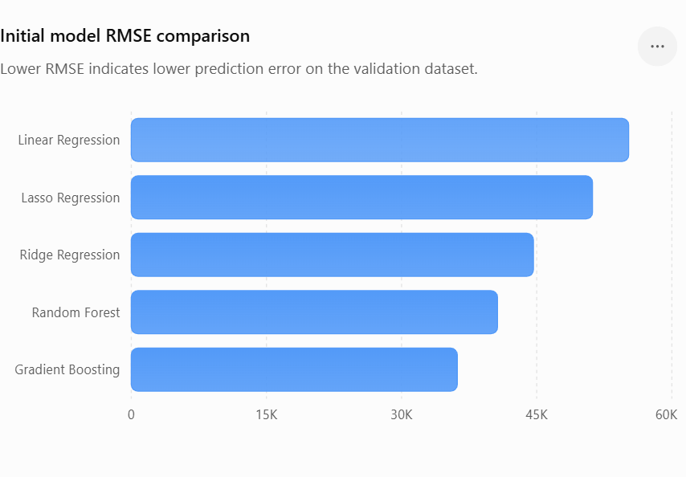

Figure 2.2 – Model RMSE Comparison.

The RMSE comparison indicates that Gradient Boosting produces the lowest prediction error among the five initial models.
The model ranking based on RMSE is:
Gradient Boosting → Random Forest → Ridge → Lasso → Linear Regression
Since lower RMSE indicates better predictive performance, Gradient Boosting was selected as the candidate model for further optimization.

2.6 Hyperparameter Optimization Objective
Although Gradient Boosting performed better than the other models, its performance can potentially be improved by selecting suitable hyperparameters.
Therefore, GridSearch CV was used to evaluate different combinations of:
- Number of estimators
- Learning rate
- Maximum tree depth
- Minimum samples per leaf
- Subsampling ratio
The tuning process evaluated 32 parameter combinations using 5-fold cross-validation, resulting in 160 model fits.
The best-performing configuration was:
Hyperparameter |  |  |  |  |  |  |  |  |  |  |  |  | Selected Value
n_estimators |  |  |  |  |  |  |  |  |  |  |  |  | 200
learning_rate |  |  |  |  |  |  |  |  |  |  |  |  | 0.1
max_depth |  |  |  |  |  |  |  |  |  |  |  |  | 3
min_samples_leaf |  |  |  |  |  |  |  |  |  |  |  |  | 2
subsample |  |  |  |  |  |  |  |  |  |  |  |  | 0.8

The tuned model achieved:
- RMSE: 35,538.86
- R²: 0.8190
This represents an improvement over the initial Gradient Boosting model.

2.7 Expected Outputs
The project is designed to produce the following outputs:
1. Property Price Prediction Model
A trained Gradient Boosting regression model capable of predicting residential property prices.
2. Model Performance Comparison
A comparison of different regression algorithms based on MSE, RMSE and R².
3. Important Feature Identification
Feature importance analysis to identify the property characteristics that contribute most strongly to the prediction.
4. Test Dataset Predictions
Predicted sale prices are generated for 292 unseen test properties.
The final prediction file contains:
Column |  | Description
Id |  | Unique property identifier
Sale Price |  | Predicted property sale price

The generated prediction file is:
predictions.csv

2.8 Advantages of the Proposed System
The proposed machine-learning system provides several advantages:
- Provides data-driven property price estimates.
- Reduces dependence on purely subjective valuation.
- Allows comparison of multiple machine-learning algorithms.
- Identifies important property characteristics.
- Handles both numerical and categorical variables.
- Uses preprocessing and feature transformation within a consistent pipeline.
- Uses hyperparameter tuning to improve model performance.
- Can generate predictions for previously unseen properties.
- Provides useful insights for real estate investment and pricing decisions.

2.9 Final Problem Statement
The objective of this project is to develop a reliable machine-learning-based property valuation system for Surprise Housing that predicts residential property sale prices using historical housing characteristics. The project also aims to identify the most influential variables affecting property prices, compare multiple regression algorithms, optimize the selected model using hyperparameter tuning, and generate predictions for unseen properties. The resulting system can support data-driven property valuation and investment decision-making in a new real estate market.

3. DATA COLLECTION AND PREPROCESSING

3.1 Dataset Description
The dataset used in this project contains residential property information along with the corresponding sale price for properties in the Ames housing dataset.
The business case assumes that Surprise Housing is evaluating a new real estate market. The supplied dataset is used to develop a predictive framework that learns the relationship between property characteristics and their historical sale prices.
The dataset is divided into two files:
- Training dataset – contains property attributes and the target variable SalePrice.
- Test dataset – contains property attributes but does not contain the target variable. It is used to generate final property price predictions.
The training dataset contains 1,168 observations and 81 columns, while the test dataset contains 292 observations and 80 columns.
The additional column in the training data is the target variable, Sale Price.

Dataset |  |  |  |  |  |  |  |  | Rows |  |  |  |  |  |  |  |  |  | Columns |  |  |  |  |  |  |  |  | Target Variable
Training Dataset |  |  |  |  |  |  |  |  | 1,168 |  |  |  |  |  |  |  |  |  | 81 |  |  |  |  |  |  |  |  | Sale Price
Test Dataset |  |  |  |  |  |  |  |  | 292 |  |  |  |  |  |  |  |  |  | 80 |  |  |  |  |  |  |  |  | Not available
Combined Property Features |  |  |  |  |  |  |  |  | — |  |  |  |  |  |  |  |  |  | 79 |  |  |  |  |  |  |  |  | —
The Id column is used only as a property identifier and is not used as a predictive feature.

3.2 Dataset Characteristics
The dataset contains a mixture of numerical and categorical variables.
After separating the identifier and target variable, the training data contains:
- 79 input features
- 36 numerical features
- 43 categorical features
- 1 target variable – SalePrice
The numerical variables describe measurable characteristics such as:
- Lot area
- Living area
- Basement area
- Garage area
- Number of rooms
- Number of bathrooms
- Year built
- Year remodelled
- Number of cars supported by the garage
The categorical variables describe characteristics such as:
- Neighbourhood
- Building type
- House style
- Exterior material
- Foundation
- Basement quality
- Garage type
- Kitchen quality
- Heating quality
- Sale type
- Sale condition

For example, the dataset description defines Overall Qual as a rating of the overall material and finish of the house on a scale from 1 (Very Poor) to 10 (Very Excellent).
Similarly, GrLivArea represents the above-grade living area in square feet, while 1stFlrSF and 2ndFlrSF represent first- and second-floor areas.

3.3 Important Dataset Variables
Some of the most relevant variables used in the project are shown below.

Feature |  |  |  |  |  |  |  |  |  |  |  | Type |  |  |  |  |  |  |  |  |  |  |  |  | Description
Id |  |  |  |  |  |  |  |  |  |  |  | Numerical |  |  |  |  |  |  |  |  |  |  |  |  | Unique property identifier
SalePrice |  |  |  |  |  |  |  |  |  |  |  | Numerical |  |  |  |  |  |  |  |  |  |  |  |  | Target variable representing property sale price
OverallQual |  |  |  |  |  |  |  |  |  |  |  | Numerical |  |  |  |  |  |  |  |  |  |  |  |  | Overall material and finish quality
OverallCond |  |  |  |  |  |  |  |  |  |  |  | Numerical |  |  |  |  |  |  |  |  |  |  |  |  | Overall condition of the house
YearBuilt |  |  |  |  |  |  |  |  |  |  |  | Numerical |  |  |  |  |  |  |  |  |  |  |  |  | Original construction year
YearRemodAdd |  |  |  |  |  |  |  |  |  |  |  | Numerical |  |  |  |  |  |  |  |  |  |  |  |  | Remodeling/addition year
LotArea |  |  |  |  |  |  |  |  |  |  |  | Numerical |  |  |  |  |  |  |  |  |  |  |  |  | Lot size in square feet
GrLivArea |  |  |  |  |  |  |  |  |  |  |  | Numerical |  |  |  |  |  |  |  |  |  |  |  |  | Above-grade living area
TotalBsmtSF |  |  |  |  |  |  |  |  |  |  |  | Numerical |  |  |  |  |  |  |  |  |  |  |  |  | Total basement area
1stFlrSF |  |  |  |  |  |  |  |  |  |  |  | Numerical |  |  |  |  |  |  |  |  |  |  |  |  | First-floor area
GarageCars |  |  |  |  |  |  |  |  |  |  |  | Numerical |  |  |  |  |  |  |  |  |  |  |  |  | Garage capacity in cars
GarageArea |  |  |  |  |  |  |  |  |  |  |  | Numerical |  |  |  |  |  |  |  |  |  |  |  |  | Garage area
FullBath |  |  |  |  |  |  |  |  |  |  |  | Numerical |  |  |  |  |  |  |  |  |  |  |  |  | Number of full bathrooms
TotRmsAbvGrd |  |  |  |  |  |  |  |  |  |  |  | Numerical |  |  |  |  |  |  |  |  |  |  |  |  | Total rooms above grade
Neighborhood |  |  |  |  |  |  |  |  |  |  |  | Categorical |  |  |  |  |  |  |  |  |  |  |  |  | Physical location within Ames city limits
MSZoning |  |  |  |  |  |  |  |  |  |  |  | Categorical |  |  |  |  |  |  |  |  |  |  |  |  | General zoning classification
HouseStyle |  |  |  |  |  |  |  |  |  |  |  | Categorical |  |  |  |  |  |  |  |  |  |  |  |  | Type/style of house
Exterior1st |  |  |  |  |  |  |  |  |  |  |  | Categorical |  |  |  |  |  |  |  |  |  |  |  |  | Exterior covering
KitchenQual |  |  |  |  |  |  |  |  |  |  |  | Categorical |  |  |  |  |  |  |  |  |  |  |  |  | Kitchen quality
GarageType |  |  |  |  |  |  |  |  |  |  |  | Categorical |  |  |  |  |  |  |  |  |  |  |  |  | Garage location/type
BsmtQual |  |  |  |  |  |  |  |  |  |  |  | Categorical |  |  |  |  |  |  |  |  |  |  |  |  | Basement quality
SaleType |  |  |  |  |  |  |  |  |  |  |  | Categorical |  |  |  |  |  |  |  |  |  |  |  |  | Type of sale

he supplied data dictionary identifies Neighbourhood as the physical location of the property within Ames city limits.
The data dictionary also identifies GarageType , GarageFinish, GarageCars, and GarageArea as garage-related variables.

3.4 Initial Data Quality Assessment
Before applying machine learning algorithms, the dataset was examined for common data-quality issues.
The main preprocessing issues identified were:
- Missing values in several variables.
- Categorical variables requiring numerical encoding.
- Numerical variables existing on different scales.
- Presence of property-absence information represented by missing values.
- The target variable having a positively skewed distribution.
- The identifier column Id not being suitable as a predictive feature.

The initial dataset did not contain duplicate rows, so no duplicate records needed to be removed.

3.5 Missing Value Analysis
Missing values were one of the most important preprocessing considerations in the housing dataset.
However, a missing value in this dataset does not always mean that information was simply unavailable. In many housing variables, missingness represents the absence of a particular property feature.
For example:
- Missing PoolQC can indicate that the property does not have a pool.
- Missing GarageType can indicate that the property does not have a garage.
- Missing BsmtQual can indicate that the property does not have a basement.
- Missing FireplaceQu can indicate that there is no fireplace.
- Missing Fence can indicate that the property does not have a fence.
3.6 Missing Value Treatment
Different strategies were used depending on the meaning and data type of the variable.
3.6.1 Categorical Features Representing Absence
For categorical variables where a missing value indicates that the corresponding facility does not exist, missing values were replaced with:
None
The following variables were treated this way:
- PoolQC
- MiscFeature
- Alley
- Fence
- FireplaceQu
- GarageType
- GarageFinish
- GarageQual
- GarageCond
- BsmtQual
- BsmtCond
- BsmtExposure
- BsmtFinType1
- BsmtFinType2
- MasVnrType

This approach preserves the information contained in the missing value instead of incorrectly treating it as an unknown category.
3.6.2 Numerical Features Representing Absence
For numerical variables where zero logically represents the absence of the corresponding feature, missing values were replaced with :0
The variables include:
- MasVnrArea
- BsmtFinSF1
- BsmtFinSF2
- BsmtUnfSF
- TotalBsmtSF
- BsmtFullBath
- BsmtHalfBath
- GarageCars
- GarageArea
For example, a property without a garage can reasonably have GarageCars = 0 and
GarageArea = 0.
Similarly, a property without a basement can have basement-related area values equal to zero.

3.6.3 Treatment of LotFrontage
LotFrontage represents the linear feet of street connected to the property.
Because its missing values do not necessarily mean that the property has no frontage, replacing the missing values with zero would be inappropriate.
Therefore, the median value from the training data was used to fill missing LotFrontage values.
The median was selected because it is less affected by extreme property sizes than the mean.
3.6.4 Treatment of GarageYrBlt
Missing values in GarageYrBlt were replaced with 0.
Here, the missing value can represent the absence of a garage rather than an unknown construction year. Using zero therefore preserves the distinction between properties with garage information and properties without a garage.
3.6.5 Treatment of Electrical
The Electrical feature contained a missing categorical value in the test data.
This was handled using the mode from the training dataset.
Using the training-set mode avoids introducing information from the test observations into the preprocessing process.
3.7 Summary of Missing Value Treatment

Category |  |  |  |  |  | Variables/Examples |  |  |  | Treatment
Categorical absence |  |  |  |  |  | PoolQC, GarageType, BsmtQual, Fence, etc. |  |  |  | "None"
Numerical absence |  |  |  |  |  | GarageArea, GarageCars, TotalBsmtSF, etc. |  |  |  | 0
Continuous variable |  |  |  |  |  | LotFrontage |  |  |  | Training median
Garage year |  |  |  |  |  | GarageYrBlt |  |  |  | 0
Isolated categorical missing value |  |  |  |  |  | Electrical |  |  |  | Training mode
Table 3.4: Missing Value Handling Strategy

3.8 Final Missing Value Verification
After completing the missing-value treatment, the dataset was checked again
Important Output
Missing values in training data: 0
Missing values in test data: 0
Dataset |  |  |  |  |  | Missing Values Before |  |  |  |  |  | Missing Values After
Training data |  |  |  |  |  | Present |  |  |  |  |  | 0
Test data |  |  |  |  |  | Present |  |  |  |  |  | 0

Table 3.5: Missing Value Check

3.9 Duplicate Record Check
Duplicate records were also checked before model development.
Duplicate rows: 0
Since no duplicate observations were detected, no records were removed on the basis of duplication.

DUPLICATE ROWS | MISSING VALUES-TRAINING | MISSING VALUES -TEST
0 | 0 | 0

Table 3.6: Data Quality Verification

3.10 Identification of Numerical and Categorical Features
After cleaning the data, the predictor variables were separated into two groups:
- 36 numerical features
- 43 categorical features
This separation was necessary because numerical and categorical variables require different preprocessing techniques.
Numerical variables include measurements such as:
- Living area
- Basement area
- Garage area
- Lot area
- Number of bathrooms
- Number of rooms
- Construction year
Categorical variables include characteristics such as:
- Neighbourhood
- Building type
- House style
- Exterior material
- Garage type
- Basement quality
- Sale condition

3.11 Categorical Variable Encoding
Machine learning algorithms require numerical input. Therefore, categorical variables were converted into numerical representations using One-Hot Encoding.
For example, a categorical variable such as Neighbourhood can contain multiple categories. One-hot encoding creates separate binary indicator variables for these categories.
This prevents the model from incorrectly assuming that categories have a natural numerical order.
The preprocessing configuration also used:
handle_unknown = "ignore"
This ensures that if a category appears in the test data that was not present during training, the transformation can still be performed without generating an error.

3.12 Numerical Feature Scaling
Numerical features have very different ranges.
For example:
- OverallQual represents a quality rating.
- GrLivArea represents area.
- YearBuilt represents a year.
- GarageCars represents capacity.
Because these variables operate on different numerical scales, StandardScaler was used for numerical features.
Standardization places numerical variables on a comparable scale, helping the linear models such as Ridge, Lasso, and Linear Regression perform more effectively.

3.13 Combined Preprocessing Pipeline
A ColumnTransformer was used to combine the numerical and categorical preprocessing operations.
The overall preprocessing sequence can be represented as:
Raw Training/Test Data
↓
Remove Identifier (Id)
↓
Separate Target (SalePrice)
↓
Identify Numerical & Categorical Features
↓
Handle Missing Values
↓
One-Hot Encode Categorical Features
↓
Standardize Numerical Features
↓
Create Model-Ready Dataset

This approach ensures that the same preprocessing logic is consistently applied during model training, validation, and final prediction.
3.14 Train–Validation Split
After preprocessing preparation, the training data was divided into training and validation subsets.
An 80:20 split was used.

Dataset |  |  |  |  |  |  |  |  |  |  |  | Number of Records |  |  |  |  |  |  |  |  |  | Percentage
Training subset |  |  |  |  |  |  |  |  |  |  |  | 934 |  |  |  |  |  |  |  |  |  | 80%
Validation subset |  |  |  |  |  |  |  |  |  |  |  | 234 |  |  |  |  |  |  |  |  |  | 20%
Total |  |  |  |  |  |  |  |  |  |  |  | 1,168 |  |  |  |  |  |  |  |  |  | 100%

Table 3.7: Train–Validation Split

A fixed random_state of 42 was used to ensure that the same observations are assigned to the training and validation sets whenever the experiment is repeated.
The validation set was kept separate from model fitting and was used to compare model performance.
3.15 Target Variable Transformation
The target variable SalePrice was examined before model training.
Property prices are positively skewed, meaning that a relatively small number of expensive properties have substantially higher prices than the majority of observations.
To reduce the effect of this skewness, the target variable was transformed using a logarithmic transformation:
Log-transformed target = log1p(SalePrice)
The transformation helps make the target distribution more suitable for regression modeling and reduces the influence of extremely high property prices.
After predictions were generated, the inverse transformation:
expm1()
was applied to return predictions to the original sale-price scale.
This is particularly important because the final business output needs to be expressed in actual property-price units rather than logarithmic values.

3.16 Final Preprocessed Dataset Summary

Parameter |  |  |  |  |  |  |  |  |  |  | Final Value
Training observations |  |  |  |  |  |  |  |  |  |  | 1,168
Test observations |  |  |  |  |  |  |  |  |  |  | 292
Predictor variables |  |  |  |  |  |  |  |  |  |  | 79
Numerical features |  |  |  |  |  |  |  |  |  |  | 36
Categorical features |  |  |  |  |  |  |  |  |  |  | 43
Missing values after preprocessing |  |  |  |  |  |  |  |  |  |  | 0
Duplicate rows |  |  |  |  |  |  |  |  |  |  | 0
Training subset |  |  |  |  |  |  |  |  |  |  | 934
Validation subset |  |  |  |  |  |  |  |  |  |  | 234
Validation ratio |  |  |  |  |  |  |  |  |  |  | 20%
Target transformation |  |  |  |  |  |  |  |  |  |  | Log1p(SalePrice)

Table 3.8: Final Dataset Readiness

4. EXPLORATORY DATA ANALYSIS (EDA)
4.1 Introduction to Exploratory Data Analysis
Exploratory Data Analysis (EDA) was performed to understand the structure, distribution, variability, and relationships present in the housing dataset before developing the predictive models.
The primary objective of EDA was to identify the factors that may have a significant influence on residential property prices. Since the target variable of the project is SalePrice, the analysis focused on understanding its distribution and examining its relationship with important numerical and categorical property characteristics.
The EDA process included:
- Analysis of the distribution of SalePrice
- Correlation analysis of numerical variables
- Analysis of property quality and sale price
- Analysis of neighborhood and sale price
- Analysis of living area and sale price
- Identification of potential outliers
- Examination of relationships among important predictors
The results obtained from EDA were subsequently used to guide feature selection, preprocessing, model development, and interpretation.

4.2 Analysis of the Target Variable – SalePrice
The first step in EDA was to examine the distribution of the target variable SalePrice.
The training dataset contains 1,168 property observations.
The descriptive statistics of SalePrice are:

The mean sale price is approximately $181,477, while the median sale price is approximately $163,995.
The fact that the mean is higher than the median indicates that the distribution is affected by relatively expensive properties.

Statistic |  |  |  |  |  |  |  |  | Value
Count |  |  |  |  |  |  |  |  | 1,168
Mean |  |  |  |  |  |  |  |  | 181,477
Median |  |  |  |  |  |  |  |  | 163,995
Minimum |  |  |  |  |  |  |  |  | 34,900
Maximum |  |  |  |  |  |  |  |  | 755,000
Table 4.1: SalePrice Descriptive Statistics

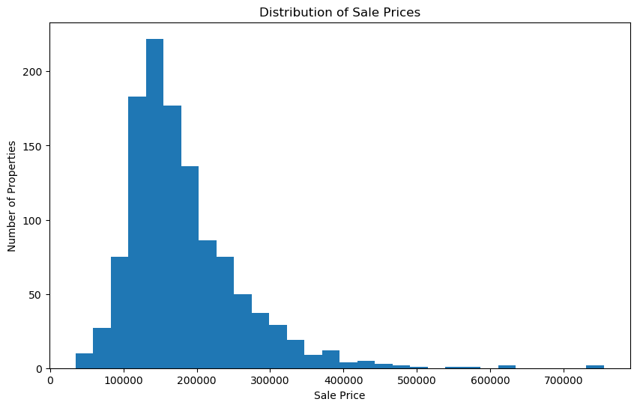
Figure 4.1 – Distribution of SalePrice
The histogram demonstrates that most properties are concentrated within lower and middle price ranges, while fewer properties have substantially higher sale prices.
Modelling implication
Because of this right-skewed distribution, the target variable was transformed using:
log1p(SalePrice)
This transformation reduces the influence of extreme target values and provides a more stable scale for regression modelling.
4.3 Correlation Analysis

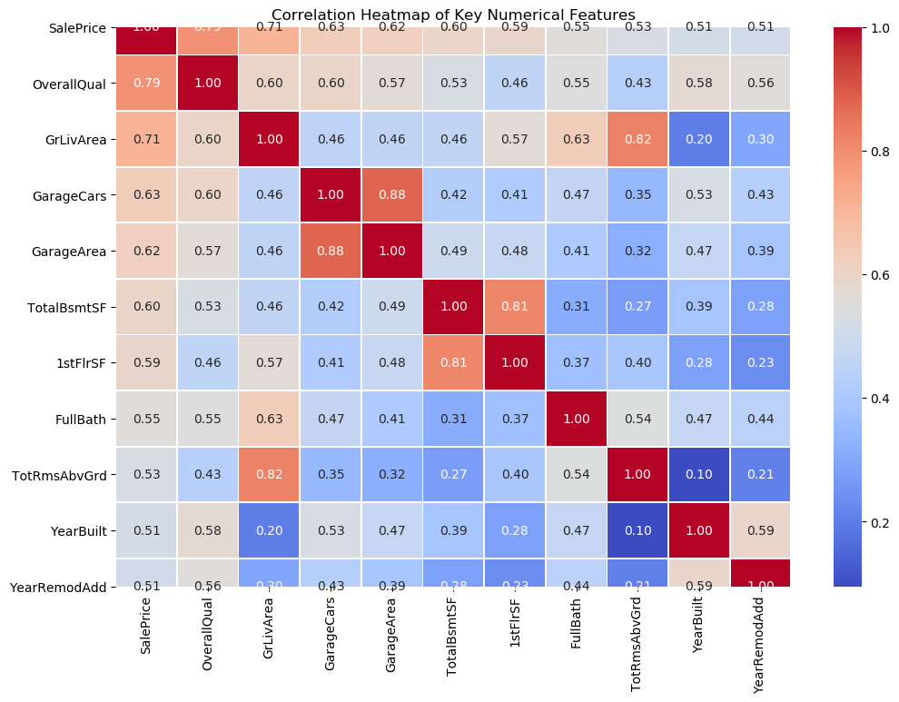
Figure 4.2 – Correlation Heatmap of Key Numerical Variables

The correlation heatmap is used to understand:
- How strongly individual numerical variables are related to SalePrice.
- Which predictors contain similar information.
- Whether multicollinearity may affect linear regression models.

The heatmap demonstrates that OverallQual has the strongest numerical relationship with SalePrice, followed by GrLivArea.
Other important variables include:
- GarageCars
- GarageArea
- TotalBsmtSF
- 1stFlrSF
- FullBath
- TotRmsAbvGrd
- YearBuilt
- YearRemodAdd
A positive correlation indicates that higher values of the feature are generally associated with higher property prices.
However, correlation should be interpreted as an association rather than causation.

4.4 OverallQual and SalePrice

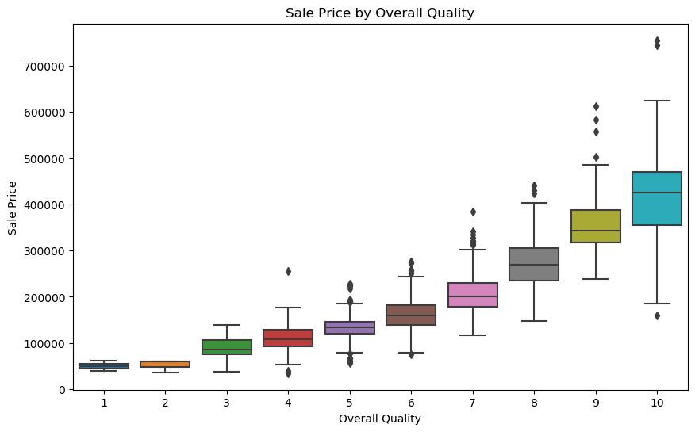

Figure 4.3 – SalePrice Distribution Across OverallQual Ratings

OverallQual represents the overall material and finish quality of the property.
The analysis shows a clear upward pattern in SalePrice as OverallQual increases.
The correlation between OverallQual and SalePrice is:
0.789185
This makes OverallQual the strongest numerical variable associated with SalePrice in the dataset.

4.5 Neighbourhood and SalePrice

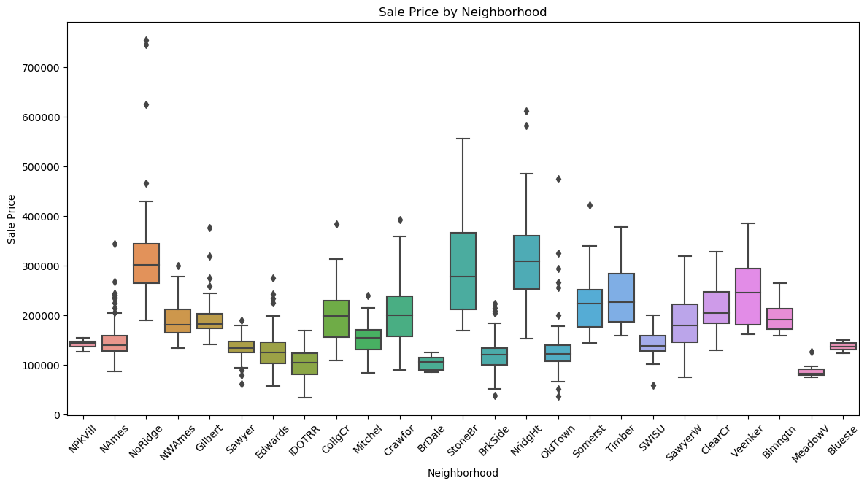
Figure 4.4 – SalePrice Distribution by Neighbourhood

Neighbourhood represents the physical location of properties within the Ames city limits.
Interpretation
The boxplot demonstrates considerable differences in SalePrice distributions across neighbourhoods.
Some neighbourhoods have:
- Higher median property prices
- Greater price dispersion
- More high-value properties
Other neighbourhoods have comparatively lower price distributions.
This demonstrates that location is an important component of property valuation.

4.6 GrLivArea and SalePrice
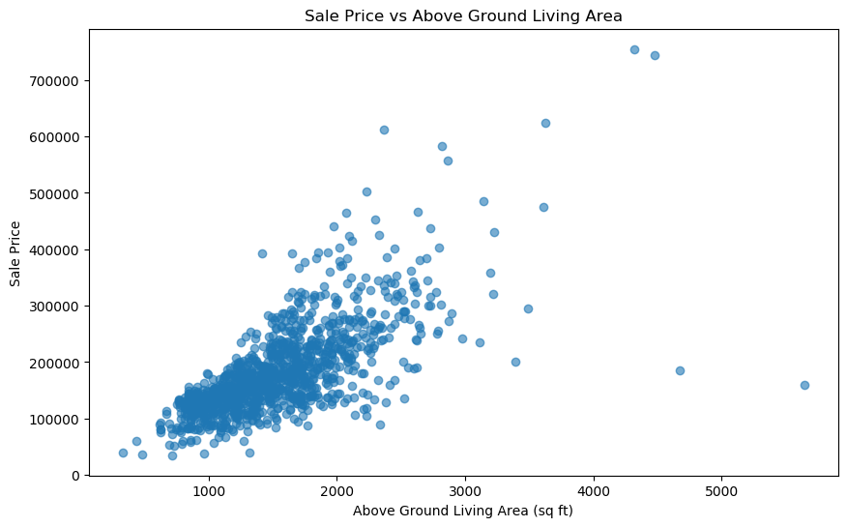

Figure 4.5 – GrLivArea vs SalePrice

GrLivArea represents the above-ground living area of the property.
The correlation between GrLivArea and SalePrice is:
0.707300
This makes it the second strongest numerical relationship with SalePrice among the major predictors.
The scatter plot demonstrates a clear positive relationship between living area and SalePrice.
Larger above-ground living area → Higher property price
However, the relationship is not perfectly linear.
Properties with similar living areas can have substantially different sale prices because of other factors such as:
- Overall quality
- Neighbourhood
- Property condition
- Garage facilities
- Basement characteristics
- Construction year
- Remodelling
The spread also becomes more noticeable at larger property sizes.

4.7 Outlier Analysis

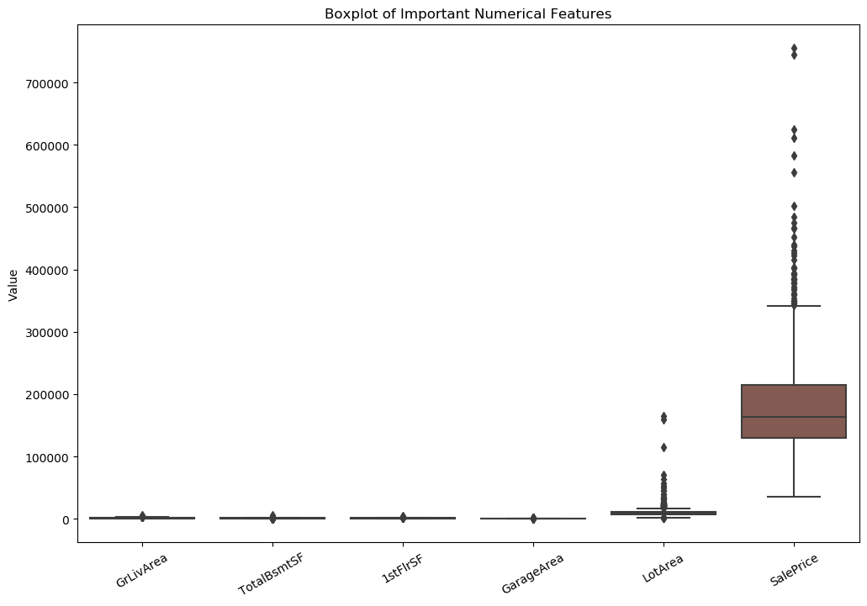
Figure 4.6 – Outlier Analysis of Important Numerical Features
The boxplot analysis identifies potential extreme observations in several important numerical variables.
In particular, the dataset contains extreme observations in:
- SalePrice
- LotArea
- GrLivArea
- TotalBsmtSF
- 1stFlrSF
- GarageArea
The presence of an outlier does not automatically mean that the observation is incorrect.
4.8 Multicollinearity Analysis
This is an important written analysis, but you do not need another separate graph because the correlation heatmap in Figure 4.2 already shows these relationships.
Several predictors are strongly correlated with each other.

Predictor 1 |  |  |  |  |  |  |  | Predictor 2 |  |  |  |  |  |  |  | Approx. Correlation
GarageCars |  |  |  |  |  |  |  | GarageArea |  |  |  |  |  |  |  | 0.88
GrLilvArea |  |  |  |  |  |  |  | TotRmsAbvGrd |  |  |  |  |  |  |  | 0.82
TotalBsmtSF |  |  |  |  |  |  |  | 1stFlrSF |  |  |  |  |  |  |  | 0.81

4.9 EDA Summary
The exploratory analysis provided several important insights into the housing dataset.First, SalePrice is right-skewed, with a mean of approximately $181,477 and a median of approximately $163,995. This supported the use of a logarithmic target transformation. Second, OverallQual showed the strongest numerical relationship with SalePrice, with a correlation of approximately 0.789, while GrLivArea showed the second strongest relationship at approximately 0.707.Third, garage, basement, first-floor, bathroom and room-related variables also demonstrated meaningful positive relationships with property prices.Fourth, property prices differed considerably across neighbourhoods, confirming that location is an important valuation factor.Finally, potential outliers and multicollinearity were identified. Rather than deleting observations automatically, the project retained the data and used appropriate transformation and modelling techniques.

5. FEATURE ENGINEERING
5.1 Objective of Feature Engineering
Feature engineering was performed to transform the original housing attributes into a format suitable for machine learning models. The main objectives were:
- Transform the target variable to reduce skewness.
- Standardize numerical predictors.
- Convert categorical variables into machine-readable numerical representations.
- Maintain consistency between training, validation, and test datasets.
- Prevent data leakage during model training and cross-validation.
The original dataset contains 79 predictor variables after removing Id and SalePrice. These consist of 36 numerical features and 43 categorical features.

5.2 Removal of the Identifier Variable
The dataset contains an Id column that uniquely identifies each property. Since this variable does not represent any physical, structural, quality, or location characteristic of the property, it was not used as a predictor.
The property IDs were stored separately before removing the column. This was necessary because the IDs are required later when creating the final test prediction file.

5.3 Numerical and Categorical Feature Identification
After separating the target variable, the predictors were divided into numerical and categorical groups.
Numerical features
There are 36 numerical features in the dataset.
Examples include:
- LotArea
- OverallQual
- OverallCond
- YearBuilt
- YearRemodAdd
- GrLivArea
- TotalBsmtSF
- 1stFlrSF
- GarageArea
- GarageCars
These variables represent quantities, measurements, years, counts, and numerical ratings.
Categorical features
There are 43 categorical features.
Examples include:
- Neighborhood
- MSZoning
- HouseStyle
- Exterior1st
- KitchenQual
- GarageType
- BsmtQual
- SaleCondition
These variables represent categories or qualitative property characteristics.

Feature Type |  |  |  | Number of Features |  |  |  |  |  | Processing
Numerical |  |  |  | 36 |  |  |  |  |  | StandardScaler
Categorical |  |  |  | 43 |  |  |  |  |  | OneHotEncoder
Total predictors |  |  |  | 79 |  |  |  |  |  | Preprocessing pipeline

This classification is important because numerical and categorical variables require different preprocessing techniques.

5.4 Target Variable Transformation
One of the most important transformations performed in the project was applied to the target variable, SalePrice.
During EDA, the target distribution was found to be right-skewed, with a relatively small number of properties having very high sale prices.
To reduce the effect of this skewness, the following transformation was applied:
$$SalePrice_{log}=log⁡\left(1+SalePrice\right)$$
In the notebook, this was implemented using:
np.log1p(SalePrice)
The transformed target was stored as y_log.
Why was the log transformation used?
The transformation was applied because it can:
- Reduce the strong right skew in property prices.
- Reduce the influence of extremely expensive properties.
- Make the target distribution more suitable for regression modeling.
- Improve numerical stability during model training.
- Allow the models to focus more effectively on relative differences in property prices.
The notebook uses the transformed target during model training.
Reverse transformation
After prediction, the logarithmic predictions were converted back to the original price scale using:
$$Predicted SalePrice=e^{Prediction_{log}}-1$$
This was implemented using np.expm1().

5.5 Numerical Feature Transformation
The 36 numerical predictors were standardized using StandardScaler.
Standardization transforms a numerical variable according to:
$$z=\frac{x-μ}{σ}$$
where:
- $x$= original feature value
- $μ$= mean of the feature
- $σ$= standard deviation
- $z$= standardized feature value
The purpose is to place numerical variables on comparable scales.
For example, housing variables such as:
- LotArea
- GrLivArea
- YearBuilt
- GarageCars
have completely different numerical ranges.
Standardization is particularly useful for the regression models used in this project, especially Ridge and Lasso Regression, where feature scale can influence the magnitude and interpretation of coefficients

5.6 Categorical Feature Transformation
The dataset contains 43 categorical features. These variables represent qualitative property characteristics such as neighborhood, building type, exterior material, kitchen quality, garage type, basement quality, and sale condition.
Machine learning algorithms such as Gradient Boosting and Ridge Regression cannot directly process string-based categorical values. Therefore, categorical variables were converted into numerical form using One-Hot Encoding.
The transformation was implemented using:
OneHotEncoder(handle_unknown="ignore")

5.7 Handling Categorical Missing Values
Several categorical variables contain missing values because the corresponding property feature is not present.
For example:
- Missing PoolQC → property has no pool
- Missing GarageType → property has no garage
- Missing BsmtQual → property has no basement
- Missing FireplaceQu → property has no fireplace
- Missing Fence → property has no fence
Therefore, these missing values should not simply be treated as unknown information.
Instead, categorical absence was explicitly represented using:
"None"
The following variables were treated this way:
Feature Group |  |  |  |  |  |  |  |  |  |  |  |  | Variables
Pool |  |  |  |  |  |  |  |  |  |  |  |  | PoolQC
Miscellaneous |  |  |  |  |  |  |  |  |  |  |  |  | MiscFeature
Alley |  |  |  |  |  |  |  |  |  |  |  |  | Alley
Fence |  |  |  |  |  |  |  |  |  |  |  |  | Fence
Fireplace |  |  |  |  |  |  |  |  |  |  |  |  | FireplaceQu
Garage |  |  |  |  |  |  |  |  |  |  |  |  | GarageType, GarageFinish, GarageQual, GarageCond
Basement |  |  |  |  |  |  |  |  |  |  |  |  | BsmtQual, BsmtCond, BsmtExposure, BsmtFinType1, BsmtFinType2
Masonry |  |  |  |  |  |  |  |  |  |  |  |  | MasVnrType

This preserves the distinction between “feature is absent” and “information is unknown.”

5.8 Handling Numerical Missing Values
Numerical variables also contained missing values. In several cases, a missing numerical value indicates that the associated property feature does not exist.
For example, if a property does not have a garage, its garage area can logically be represented as zero.
Feature |  |  |  |  | Missing Value Representation
MasVnrArea |  |  |  |  | 0
BsmtFinSF1 |  |  |  |  | 0
BsmtFinSF2 |  |  |  |  | 0
BsmtUnfSF |  |  |  |  | 0
TotalBsmtSF |  |  |  |  | 0
BsmtFullBath |  |  |  |  | 0
BsmtHalfBath |  |  |  |  | 0
GarageCars |  |  |  |  | 0
GarageArea |  |  |  |  | 0

For GarageYrBlt, missing values were also represented as 0, indicating that the property does not have a garage.
LotFrontage
LotFrontage represents the linear feet of street connected to the property.
Because a missing value here does not necessarily mean that the property has zero frontage, it was handled differently.
The missing LotFrontage values were replaced using the training-data median..
5.6 Feature Engineering Workflow
The complete feature engineering and preparation process can be summarized as follows
Original Dataset
↓
Remove Id
↓
Separate SalePrice
↓
Identify Numerical & Categorical Features
↓
Handle Missing Values
↓
Log Transformation of SalePrice
↓
80:20 Train–Validation Split
↓
Numerical Features → StandardScaler
↓
Categorical Features → One-Hot Encoding
↓
ColumnTransformer
↓
Model Pipeline
↓
Machine Learning Models
5.7 Target Variable Transformation
Although this was introduced earlier, it is important to summarize it here because it is part of the final modeling preparation.
The SalePrice variable showed a right-skewed distribution.
To reduce the effect of extreme high-priced properties, the target was transformed using:
$$y_{log}=log⁡\left(1+y\right)$$
implemented as:
y_log = np.log1p(y)
The model was trained using this transformed target.
After prediction, the values were converted back to the original price scale using:
$$y=exp⁡\left(y_{log}\right)-1$$
implemented as:
np.expm1(predictions)

This allowed the model to work with a more stable target distribution while keeping the final predictions interpretable as actual property prices.
6. MODEL SELECTION AND TRAINING
6.1 Introduction
The objective of the modeling stage is to develop a reliable machine learning model capable of predicting residential property sale prices based on property characteristics such as overall quality, living area, basement area, garage features, neighborhood, construction year, and other structural and categorical attributes.
Since house prices are influenced by both linear relationships and complex nonlinear interactions, multiple regression algorithms were considered. The models were trained using the same preprocessed dataset and evaluated on the same validation set to ensure a fair comparison.
The following five models were selected:
- Linear Regression
- Ridge Regression
- Lasso Regression
- Random Forest Regression
- Gradient Boosting Regression
The models were deliberately selected to represent different modelling approaches, ranging from a simple linear baseline to regularized linear models and nonlinear ensemble techniques.
6.2 Model Selection Strategy
The model selection strategy was based on the following considerations:
- Establishing a simple baseline model.
- Handling multicollinearity among numerical variables.
- Controlling model complexity through regularization.
- Capturing nonlinear relationships.
- Capturing interactions between property characteristics.
- Comparing interpretable models with high-performing ensemble models.
The overall strategy was:
Linear Regression → Ridge/Lasso → Random Forest → Gradient Boosting
This progression allowed the project to determine whether increasing model complexity resulted in improved predictive performance.
6.3 Common Training Framework
Before training, the dataset underwent the preprocessing and feature engineering procedures described in Sections 3–5.
The target variable SalePrice was transformed using:
$$y_{log}=log⁡\left(1+SalePrice\right)$$
This transformation was used because property prices are positively skewed, and the logarithmic transformation reduces the influence of extremely high-priced properties.
The dataset was then divided into:
- Training set: 934 observations
- Validation set: 234 observations
A fixed random_state = 42 was used to ensure reproducibility.
Preprocessing
Numerical variables were standardized using:
StandardScaler
Categorical variables were converted into numerical representations using:
OneHotEncoder(handle_unknown="ignore")
A ColumnTransformer was used so that numerical and categorical variables could be processed appropriately within the same modeling pipeline.
This ensured that the same preprocessing procedure was applied consistently across all models.
6.4 Linear Regression
Model Description
Linear Regression was used as the baseline model.
The model assumes that the target variable can be represented as a linear combination of the input variables:
$$\hat{y}=β_{0}+β_{1}X_{1}+β_{2}X_{2}+⋯+β_{n}X_{n}$$
where:
- $\hat{y}$= predicted log sale price
- $β_{0}$= intercept
- $β_{i}$= coefficient of feature $X_{i}$
Rationale
Linear Regression was selected because:
- It is simple and computationally efficient.
- It provides an easy-to-understand baseline.
- Its coefficients provide directional information about relationships between features and price.
- It provides a benchmark against which more advanced models can be compared.
However, housing prices are unlikely to be governed entirely by linear relationships. Therefore, Linear Regression was primarily used as a baseline rather than as the expected final model.
Training
The model was trained using the standardized numerical features and one-hot encoded categorical features.
No regularization was applied.
6.5 Ridge Regression
Model Description
Ridge Regression extends Linear Regression by adding an L2 regularization penalty.
$$\min_{β}\left[\sum{(}\left.y_{i}-\hat{y_{i}}{\left.)\right.}^{2}+α\sum{β_{j}^{2}}\right]\right.$$
The regularization parameter used for the initial model was:
α = 10
Rationale
Ridge Regression was selected because the dataset contains several highly correlated variables.
For example:
- GarageCars and GarageArea
- GrLivArea and TotRmsAbvGrd
- TotalBsmtSF and 1stFlrSF
When predictor variables are strongly correlated, ordinary linear regression coefficients can become unstable.
Ridge regression reduces this problem by shrinking coefficients toward zero.
Training
The model was trained using the same:
- training/validation split,
- numerical scaling,
- categorical encoding,
- log-transformed target.
This allowed Ridge to be compared fairly with the other models.
6.6 Lasso Regression
Model Description
Lasso Regression applies L1 regularization:
$$\min_{β}\left[\sum{(}\left.y_{i}-\hat{y_{i}}{\left.)\right.}^{2}+α\sum{∣}β_{j}∣\right]\right.$$
The initial configuration used:
- alpha = 0.0005
- max_iter = 10000
Rationale
Lasso was included because L1 regularization can shrink some coefficients completely to zero.
This provides an implicit form of feature selection and can be useful when the dataset contains a large number of one-hot encoded categorical variables.
Training
Lasso was trained using the same preprocessing pipeline and log-transformed target variable.
It provided an additional regularized linear benchmark against Ridge Regression.
6.7 Random Forest Regression
Model Description
Random Forest is an ensemble learning algorithm that combines multiple decision trees.
The initial model used:
- n_estimators = 300
- max_depth = None
- min_samples_split = 2
- min_samples_leaf = 1
- random_state = 42
Rationale
Random Forest was selected because housing prices often exhibit nonlinear relationships.
For example, the effect of living area on price may depend on:
- neighborhood,
- overall quality,
- construction year,
- garage availability,
- basement characteristics.
Random Forest can capture such nonlinear relationships and interactions without requiring them to be explicitly specified.
Advantages
- Captures nonlinear relationships.
- Handles feature interactions.
- Less dependent on linear assumptions.
- Provides feature importance information.
- Generally robust to complex datasets.
Training
Multiple decision trees were trained on different samples of the training data. Their predictions were combined to produce the final Random Forest prediction.
6.8 Gradient Boosting Regression
Model Description
Gradient Boosting was selected as the second major nonlinear ensemble model.
The initial configuration used:
- n_estimators = 300
- learning_rate = 0.05
- max_depth = 3
- min_samples_leaf = 2
- subsample = 0.8
- random_state = 42
Rationale
Gradient Boosting builds models sequentially. Each new tree attempts to correct errors made by the previous trees.
This makes Gradient Boosting particularly useful for structured/tabular datasets such as housing data.
It can capture:
- nonlinear relationships,
- feature interactions,
- complex pricing patterns,
- diminishing or increasing effects of property characteristics.
The model was expected to perform strongly because the relationship between property characteristics and sale price is not purely linear.
6.9 Initial Model Comparison.
Model |  |  |  |  |  |  |  | MSE |  |  |  |  |  |  |  | RMSE |  |  |  |  |  |  |  |  |  |  | R²
Linear Regression |  |  |  |  |  |  |  | 3,047,744,473.61 |  |  |  |  |  |  |  | $55,206.38 |  |  |  |  |  |  |  |  |  |  | 0.5632
Ridge Regression |  |  |  |  |  |  |  | 1,992,358,970.42 |  |  |  |  |  |  |  | $44,635.85 |  |  |  |  |  |  |  |  |  |  | 0.7144
Lasso Regression |  |  |  |  |  |  |  | 2,620,984,962.60 |  |  |  |  |  |  |  | $51,195.56 |  |  |  |  |  |  |  |  |  |  | 0.6243
Random Forest |  |  |  |  |  |  |  | 1,652,410,402.01 |  |  |  |  |  |  |  | $40,649.85 |  |  |  |  |  |  |  |  |  |  | 0.7632
Gradient Boosting |  |  |  |  |  |  |  | 1,308,895,399.34 |  |  |  |  |  |  |  | $36,178.66 |  |  |  |  |  |  |  |  |  |  | 0.8124
Table 6.1 – Initial Model Performance
6.10 Model Training Procedure
The overall training procedure can be summarized as:
This framework ensured that every model was trained and evaluated under consistent conditions.

Raw Housing Data
↓
Data Cleaning
↓
Missing Value Treatment
↓
Remove ID
↓
Separate Features and Target
↓
Log Transform SalePrice
↓
Train-Validation Split
↓
Numerical Scaling
+
Categorical One-Hot Encoding
↓
Model Training
↓
Linear / Ridge / Lasso /
Random Forest / Gradient Boosting
↓
Validation Prediction
↓
MSE, RMSE and R²
↓
Model Comparison

7. Hyperparameter Tuning
7.1 Introduction
After comparing the initial models, Gradient Boosting produced the best validation performance. Therefore, it was selected for further optimization through hyperparameter tuning.
Hyperparameters control how a machine learning model learns. Appropriate tuning can improve predictive performance while controlling model complexity and overfitting.

7.2 Tuning Technique
GridSearchCV with 5-fold cross-validation was used.
Grid Search systematically evaluates combinations of predefined hyperparameter values.
The training data was divided into five folds. In each iteration:
- Four folds were used for training.
- One fold was used for validation.
- The process was repeated five times.
- The average cross-validation performance was used to identify the best configuration.
The scoring metric was:
Negative Mean Squared Error
because GridSearchCV maximizes scoring functions, so MSE is represented as its negative value.
7.3 Hyperparameter Grid
The following compact search grid was used:
Hyperparameter |  |  |  |  |  | Values Tested
n_estimators |  |  |  |  |  | 200, 300
learning_rate |  |  |  |  |  | 0.05, 0.10
max_depth |  |  |  |  |  | 2, 3
min_samples_leaf |  |  |  |  |  | 2, 4
subsample |  |  |  |  |  | 0.8, 1.0

This produced:
$$2×2×2×2×2=32$$
different combinations.
With 5-fold cross-validation:
$$32×5=160$$
model fits were performed.
n_jobs=1 was used to maintain computational stability in the user's Python environment.

7.4 Optimal Hyperparameters
The best configuration obtained was:
Hyperparameter |  |  |  |  |  |  |  |  |  |  | Optimal Value
n_estimators |  |  |  |  |  |  |  |  |  |  | 200
learning_rate |  |  |  |  |  |  |  |  |  |  | 0.10
max_depth |  |  |  |  |  |  |  |  |  |  | 3
min_samples_leaf |  |  |  |  |  |  |  |  |  |  | 2
subsample |  |  |  |  |  |  |  |  |  |  | 0.8

The best cross-validation score was:
-0.01856217742684521
This value represents negative MSE on the log-transformed target and should not be interpreted as a dollar-based RMSE.

7.5 Effect of Tuning

Metric |  |  |  |  |  |  |  |  | Initial GB |  |  |  |  |  |  | Tuned GB |  | Improvement
MSE |  |  |  |  |  |  |  |  | 1,308,895,399.34 |  |  |  |  |  |  | 1,263,010,426.78 |  | Lower
RMSE |  |  |  |  |  |  |  |  | $36,178.66 |  |  |  |  |  |  | $35,538.86 |  | $639.80 lower
R² |  |  |  |  |  |  |  |  | 0.8124 |  |  |  |  |  |  | 0.8190 |  | +0.0066

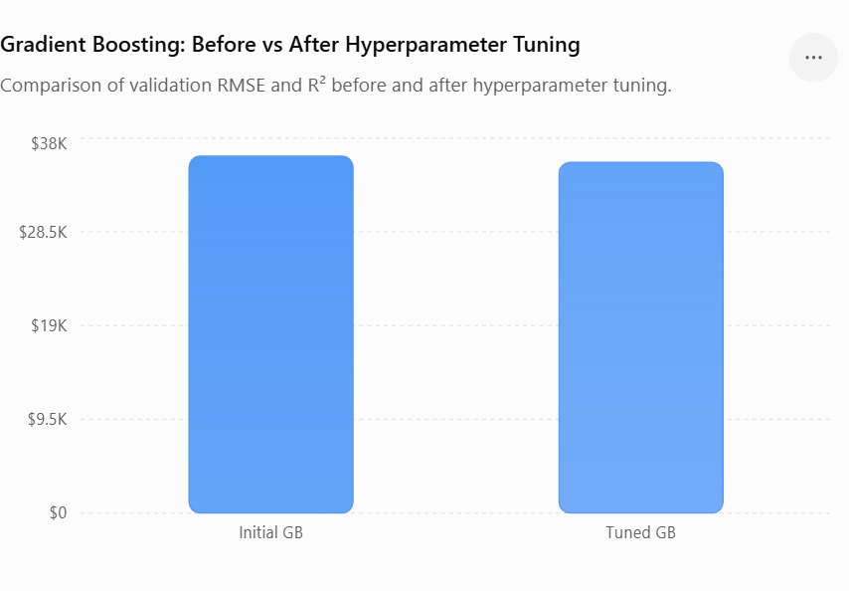

Figure 7.1: Comparison of Gradient Boosting validation RMSE before and after hyperparameter tuning

The graph shows that hyperparameter tuning reduced the validation RMSE from $36,178.66 to $35,538.86. This represents an improvement of approximately $639.80 in RMSE. The corresponding R² score also improved from 0.8124 to 0.8190, demonstrating that the optimized Gradient Boosting configuration achieved better predictive performance.

8. Model Evaluation
8.1 Evaluation Metrics
Three primary metrics were used to evaluate model performance.
Mean Squared Error – MSE
$$MSE=\frac{1}{n}\sum{(}\left.y_{i}-{\hat{y}}_{i}{\left.)\right.}^{2}\right.$$
MSE penalizes larger prediction errors more strongly because the errors are squared.
Lower MSE indicates better performance.
Root Mean Squared Error – RMSE
$$RMSE=\sqrt{MSE}$$
RMSE is easier to interpret because it is expressed in the same units as the original target variable after inverse transformation.
Lower RMSE indicates better predictive accuracy.
R² Score
$$R^{2}=1-\frac{SS_{res}}{SS_{tot}}$$
R² represents the proportion of variation in property prices explained by the model.
Higher R² indicates better explanatory/predictive performance.

8.2 Final Model Evaluation
The tuned Gradient Boosting model achieved:
Metric |  |  |  |  | Validation Performance
MSE |  |  |  |  | 1,263,010,426.78
RMSE |  |  |  |  | $35,538.86
R² |  |  |  |  | 0.8190
MAE |  |  |  |  | $18,443.15

The model's mean prediction error was approximately $2,611.84.
The minimum and maximum prediction errors were approximately:
- Minimum error: -$200,077.37
- Maximum error: $268,179.89
These extreme errors indicate that some properties remain difficult to predict accurately, particularly unusual or high-value properties.

8.3 Comparison of Models
For the final comparison, the tuned Gradient Boosting model is compared against the initial models.

Model |  |  |  |  |  |  |  |  | RMSE |  |  |  |  |  |  |  |  |  |  |  | R²
Linear Regression |  |  |  |  |  |  |  |  | $55,206.38 |  |  |  |  |  |  |  |  |  |  |  | 0.5632
Lasso Regression |  |  |  |  |  |  |  |  | $51,195.56 |  |  |  |  |  |  |  |  |  |  |  | 0.6243
Ridge Regression |  |  |  |  |  |  |  |  | $44,635.85 |  |  |  |  |  |  |  |  |  |  |  | 0.7144
Random Forest |  |  |  |  |  |  |  |  | $40,649.85 |  |  |  |  |  |  |  |  |  |  |  | 0.7632
Gradient Boosting |  |  |  |  |  |  |  |  | $36,178.66 |  |  |  |  |  |  |  |  |  |  |  | 0.8124
Tuned Gradient Boosting |  |  |  |  |  |  |  |  | $35,538.86 |  |  |  |  |  |  |  |  |  |  |  | 0.8190

8.4 Best Performing Model
The Tuned Gradient Boosting Regression model was selected as the final model.
It achieved:
- RMSE = $35,538.86
- R² = 0.8190
- MSE = 1,263,010,426.78
Why did Gradient Boosting perform best?
The likely reason is that property prices depend on complex and nonlinear interactions between features.
For example:
- Overall quality can affect the value of additional living space.
- Living area may have different price effects across neighborhoods.
- Garage and basement characteristics can interact with overall house quality.
- Age and remodeling can influence the value of otherwise similar properties.
Gradient Boosting can capture these relationships more effectively than a purely linear model.
The tuning process further improved the model by finding a more suitable combination of tree depth, learning rate, number of trees, minimum leaf size, and subsampling.

8.5 Evaluation
The validation metrics provide evidence of good predictive performance, but the model should not be interpreted as perfectly accurate.
The validation R² of approximately 0.819 means that the model explains a substantial proportion of the variation in the validation property prices, while some variation remains unexplained.
Therefore, predictions should be used as a decision-support tool, rather than as the sole basis for property investment decisions.

9. Feature Importance Analysis
9.1 Introduction
Feature importance analysis was performed using the tuned Gradient Boosting model to determine which property characteristics contributed most strongly to its predictions.
This analysis helps translate the machine learning model into business insights.

9.2 Top Important Features
The most important variables identified by the tuned Gradient Boosting model were:
Rank | Feature | Importance
1 | OverallQual | 0.472691
2 | GrLivArea | 0.151039
3 | TotalBsmtSF | 0.047867
4 | GarageArea | 0.035495
5 | YearRemodAdd | 0.031314
6 | BsmtFinSF1 | 0.021154
7 | GarageYrBlt | 0.020933
8 | 1stFlrSF | 0.018434
9 | LotArea | 0.017221
10 | YearBuilt | 0.015419

9.3 Overall Quality
OverallQual was by far the most important variable.
Its importance was approximately:
47.27%
This indicates that the overall quality rating plays a dominant role in the model's prediction process.
Higher-quality properties generally tend to command higher prices because quality captures several aspects of the property, including construction material, workmanship, and overall finish.

9.4 Above-Grade Living Area
GrLivArea was the second most important feature with an importance of approximately:
15.10%
Larger above-ground living space generally provides greater usable residential space and therefore tends to be associated with higher property values.

9.5 Basement Area
TotalBsmtSF had an importance of approximately:
4.79%
This indicates that basement size contributes meaningfully to property valuation.

9.6 Garage Characteristics
Garage-related variables also had meaningful importance.
For example:
- GarageArea: 3.55%
- GarageYrBlt: 2.09%
- GarageCars: 1.54%
This suggests that garage availability, capacity, and characteristics contribute to property valuation.

9.7 Remodeling and Construction Age
YearRemodAdd had an importance of approximately:
3.13%
This indicates that the year of remodeling is relevant to price prediction.
YearBuilt also contributed approximately:
1.54%
Together, these variables indicate that the age and modernization of a property are important components of its value.

9.8 Positive and Negative Influence Analysis
The Ridge model's coefficients were also examined to understand the direction of association between selected features and predicted log price.
Examples of positive coefficients
Feature | Coefficient
OverallQual | +0.090906
Neighborhood_Crawfor | +0.086660
Neighborhood_StoneBr | +0.071251
GrLivArea | +0.067316
Functional_Typ | +0.057352
Exterior1st_BrkFace | +0.053911
1stFlrSF | +0.053397
Neighborhood_Somerst | +0.052916
GarageCars | +0.045850

These positive coefficients indicate a positive association with predicted log sale price within the fitted Ridge model.

Examples of negative coefficients
Feature | Coefficient
MSZoning_C (all) | -0.111590
RoofMatl_ClyTile | -0.097641
Neighborhood_IDOTRR | -0.063287
SaleCondition_Abnorml | -0.062308
Neighborhood_Edwards | -0.057850
LotShape_IR3 | -0.053396
GarageCond_Fa | -0.051699
Functional_Maj2 | -0.047021
BldgType_Twnhs | -0.046514
Neighborhood_MeadowV | -0.040789

These coefficients indicate negative associations within the Ridge model.
These coefficients should not be interpreted as causal effects.
A negative coefficient does not necessarily mean that changing the feature would directly decrease the price. Categorical variables, correlations among predictors, category frequency, and the encoding structure can all affect coefficient values.
Therefore:
- Gradient Boosting feature importance tells us which variables the nonlinear model relied on most.
- Ridge coefficients provide directional associations.
These two analyses answer different questions and should not be treated as identical measures.

9.9 Required Graph

The feature importance analysis indicates that OverallQual is the most influential predictor of SalePrice, with an importance of approximately 47.27%. GrLivArea is the second most important feature at approximately 15.10%, followed by TotalBsmtSF, GarageArea, and YearRemodAdd. These results suggest that overall construction quality, above-ground living area, basement area, garage characteristics, and property renovation are important factors influencing predicted property values.
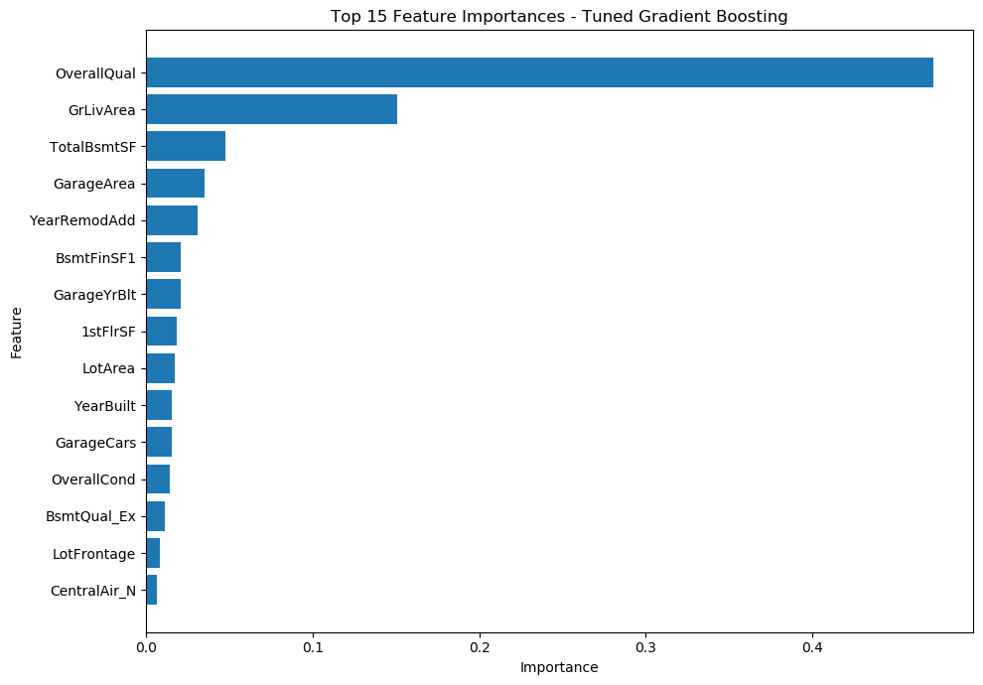

Figure 9.1: Top Feature Importances from the Tuned Gradient Boosting Model

10. Business Implications
10.1 Introduction
The purpose of the project is not simply to predict house prices. The model is intended to help Surprise Housing make better investment decisions when entering a new real estate market.
The model can support decisions related to:
- property acquisition,
- valuation,
- renovation,
- pricing,
- market screening,
- investment prioritization.
10.2 Identifying High-Value Property Characteristics
The feature importance analysis indicates that OverallQual and GrLivArea are particularly important.
Therefore, Surprise Housing can prioritize properties that combine:
- strong overall quality,
- adequate living space,
- good basement facilities,
- useful garage facilities,
- modernized interiors.
Such properties may have stronger resale potential.
10.3 Property Acquisition Strategy
The predictive model can be used during property screening.
For each candidate property, the company can:
- Collect property characteristics.
- Input them into the model.
- Obtain an estimated sale price.
- Compare the predicted price with the acquisition cost.
- Identify potentially attractive investment opportunities.
For example, if a property has a relatively low acquisition cost but the model predicts a significantly higher market value, it may deserve further investigation.
However, such a difference should be validated against actual market conditions before investment.
10.4 Renovation Strategy
Feature importance can also help determine which property characteristics deserve attention during renovation.
Because overall quality, living area, remodeling year, basement characteristics, and garage characteristics contribute significantly to predictions, the company can prioritize improvements that increase property quality and usability.
Instead of renovating every property extensively, Surprise Housing could use model insights to prioritize properties where improvements are expected to have greater commercial value.
10.5 Pricing Strategy
The model can also support property pricing.
After acquiring or renovating a property, the predicted sale price can serve as one reference point for setting an initial asking price.
This can help the company:
- avoid substantial underpricing,
- identify potentially overpriced properties,
- establish a data-driven pricing range,
- improve consistency across property evaluations.
The model should be combined with current market comparables and professional valuation practices.
10.6 Market Screening
The model can help Surprise Housing identify which property characteristics are associated with higher predicted values.
This can support market screening by helping the company answer questions such as:
- Which types of properties are likely to have stronger values?
- Which characteristics are associated with higher predicted prices?
- Which properties should receive further due diligence?
- Which renovation opportunities appear potentially attractive?
10.7 Potential for Higher Returns
The model can contribute to higher investment returns by improving the quality of acquisition and pricing decisions.
A data-driven strategy can reduce the risk of:
- overpaying for properties,
- underestimating property values,
- investing heavily in low-potential properties,
- applying the same renovation strategy to every property.
The model therefore functions as a decision-support system rather than an autonomous investment system.
10.8 Important Business Limitation
The supplied dataset represents residential properties from the Ames housing dataset. Therefore, the results should not automatically be assumed to represent the conditions of a different target market.
The business case assumes that Surprise Housing is expanding into a new real estate market, but actual deployment would require:
- local market data,
- current transaction prices,
- local economic conditions,
- neighborhood-level information,
- demand trends,
- interest rates,
- local regulations.
Consequently, the current model should be considered a predictive modeling framework that requires local validation before commercial deployment.
11. Conclusion and Future Steps
Conclusion
This project, “Enhancing Real Estate Investment Decisions with Predictive Modeling,” successfully developed a machine learning-based approach for predicting residential property prices and identifying the factors that significantly influence property values. The supplied housing dataset was systematically analyzed through data preprocessing, exploratory data analysis, feature transformation, model development, hyperparameter tuning, and final prediction generation.
Five regression models—Linear Regression, Ridge Regression, Lasso Regression, Random Forest Regression, and Gradient Boosting Regression—were compared using Mean Squared Error (MSE), Root Mean Squared Error (RMSE), and R² score. Among the evaluated models, Gradient Boosting Regression provided the best initial performance. Further hyperparameter optimization improved its performance, resulting in a final validation RMSE of $35,538.86 and an R² score of 0.8190. This indicates that the tuned model was able to explain approximately 81.9% of the variation in property sale prices in the validation data.
The feature importance analysis showed that OverallQual was the most influential feature, followed by GrLivArea, TotalBsmtSF, GarageArea, and YearRemodAdd. These findings demonstrate that property quality, living area, basement area, garage characteristics, and renovation history are important considerations when estimating property prices. The final optimized model was retrained on the complete training dataset and successfully generated price predictions for 292 test properties, which were stored in the required predictions.csv file.
Overall, the project demonstrates that predictive modeling can provide valuable data-driven support for real-estate valuation, investment analysis, and pricing decisions. However, model predictions should be treated as decision-support estimates rather than exact market values, since actual property prices may also depend on external market conditions and factors not included in the dataset.
FUTURE STEPS
The project can be further improved by evaluating advanced machine learning algorithms such as XGBoost, LightGBM, and CatBoost and comparing their performance with the tuned Gradient Boosting model. Additional feature engineering can be explored by creating meaningful variables such as total living area, property age, total bathrooms, and total finished area.
Future versions of the system could also incorporate external real-estate and economic data, including neighborhood-level market trends, recent comparable property prices, property tax information, interest rates, and local development indicators. This could improve the model's ability to reflect changing market conditions.
Further improvements can include larger datasets, extensive cross-validation, automated hyperparameter optimization, explainable AI techniques, and deployment through a web-based property valuation application. Such an application could allow users or real-estate professionals to enter property characteristics and obtain an estimated selling price along with the major factors influencing the prediction.
Thus, the developed system provides a strong foundation for intelligent real-estate price prediction and can be extended into a practical decision-support solution for property investment and valuation.

